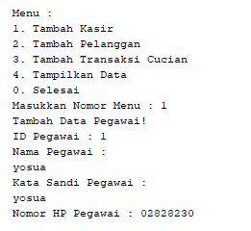

Keterangan Source Code :

------------------------------------------------------------------------------------------------------------------------------------------------------------------------------------------------------------------------------------------------------------------------------------------------------------------------------------------------------------------------------------------------------------------------------------------------------------------------------------------------------------------------------------------------------------------------------------------------------------------------------------------------------------------------------------------------------------------------------------------------------------------------------------------------------------------------------------------------------------------------------------------------------------------------------------------------------------------------------------------------------------------------------------------------------------------------------------------------------------------------------------------------------------------------------------------------------------------------------------------------------------------------------------------------------------------------------------------------------------------------------------------------------------------------------------------------------------------------------------------------------------------------------------------------------------------------------------------------------------------------------------------------

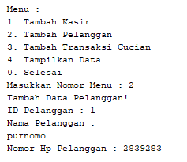

Keterangan Source Code :

------------------------------------------------------------------------------------------------------------------------------------------------------------------------------------------------------------------------------------------------------------------------------------------------------------------------------------------------------------------------------------------------------------------------------------------------------------------------------------------------------------------------------------------------------------------------------------------------------------------------------------------------------------------------------------------------------------------------------------------------------------------------------------------------------------------------------------------------------------------------------------------------------------------------------------------------------------------------------------------------------------------------------------------------------------------------------------------------------------------------------------------------------------------------------------------------------------------------------------------------------------------------------------------------------------------------------------------------------------------------------------------------------------------------------------------------------------------------------------------------------------------------------------------------------------------------------------------------------------------------------------------------

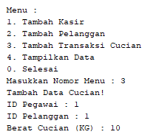

Keterangan Source Code :

------------------------------------------------------------------------------------------------------------------------------------------------------------------------------------------------------------------------------------------------------------------------------------------------------------------------------------------------------------------------------------------------------------------------------------------------------------------------------------------------------------------------------------------------------------------------------------------------------------------------------------------------------------------------------------------------------------------------------------------------------------------------------------------------------------------------------------------------------------------------------------------------------------------------------------------------------------------------------------------------------------------------------------------------------------------------------------------------------------------------------------------------------------------------------------------------------------------------------------------------------------------------------------------------------------------------------------------------------------------------------------------------------------------------------------------------------------------------------------------------------------------------------------------------------------------------------------------------------------------------------------------------

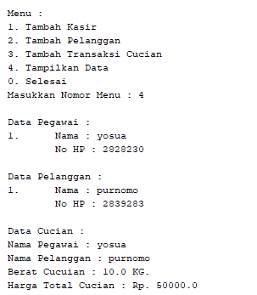

Keterangan Source Code :

------------------------------------------------------------------------------------------------------------------------------------------------------------------------------------------------------------------------------------------------------------------------------------------------------------------------------------------------------------------------------------------------------------------------------------------------------------------------------------------------------------------------------------------------------------------------------------------------------------------------------------------------------------------------------------------------------------------------------------------------------------------------------------------------------------------------------------------------------------------------------------------------------------------------------------------------------------------------------------------------------------------------------------------------------------------------------------------------------------------------------------------------------------------------------------------------------------------------------------------------------------------------------------------------------------------------------------------------------------------------------------------------------------------------------------------------------------------------------------------------------------------------------------------------------------------------------------------------------------------------------------------------

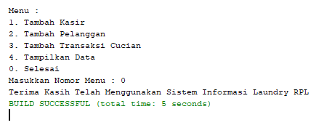

Keterangan Source Code :

------------------------------------------------------------------------------------------------------------------------------------------------------------------------------------------------------------------------------------------------------------------------------------------------------------------------------------------------------------------------------------------------------------------------------------------------------------------------------------------------------------------------------------------------------------------------------------------------------------------------------------------------------------------------------------------------------------------------------------------------------------------------------------------------------------------------------------------------------------------------------------------------------------------------------------------------------------------------------------------------------------------------------------------------------------------------------------------------------------------------------------------------------------------------------------------------------------------------------------------------------------------------------------------------------------------------------------------------------------------------------------------------------------------------------------------------------------------------------------------------------------------------------------------------------------------------------------------------------------------------------------------------